Project Course in Chemistry, KASN01

An investigation of the influence of deep discharged nickel hydroxide electrode

Jeanette Karlsson

Johanna Nilsson

Tim Nilsson

Emma Welinder

Supervisors: Sven Lidin and Rune Sjövall

2016-05-19

# Abstract

SAFT AB is a company that manufactures nickel cadmium batteries to back-up systems for example hospitals and railway gates. The batteries have high expectations since they are expected to operate at any time under various conditions. The exposing to varying climates and usage may have an effect on its effectiveness in the long run. Another factor that can also affect the capacity of the battery is deep discharging. In the following project, experiments with varying times of deep discharge has been made to try to make a connection between the deep discharge time and the effect it has on the capacity and efficiency at different temperatures and with different electrolytes. XRD has also been used to analyze the results. It was difficult to see any results that only depended on the deep discharge since other factors such as temperature and different errors may have had an influence on the samples.

Table of Contents

Introduction 4

Project Description 4

Background 4

Literature Study 5

Nickel Cadmium Battery 5

X-Ray Powder Diffraction 6

Method 8

Results and Discussion 10

Conclusion 16

References 17

Appendix 1 18

Appendix 2 19

Appendix 3 28

Appendix 4 29

# Introduction

## Project Description

The aim of this project was to investigate the influence of a deep discharged Ni(OH)2 electrod at different deep discharge times and at different temperatures. Two different electrolytes were also used for comparison. Thereafter, the samples were investigated in a XRD and the particle sizes of the different samples were compared with each other to see if deep discharge changes its structure. The project was done in partnership with SAFT AB in Oskarshamn, Sweden.

## Background

The nickel cadmium battery is an old invention, created in 1899 by Waldemar Jungner. By then, there was one competitor, the lead-acid battery. Jungner did some minor improvements in the Ni-Cd battery, the energy density increased and became greater than for the lead-acid batteries. The work of Waldemar Jungner was unknown in the USA and at the same time, Thomas Edison patented a NiCd battery in 1902. Jungner established a factory close to Oskarshamn in 1906, which nowadays is called SAFT AB. SAFT AB is stationed in 18 countries and has over 400 employees in Sweden. SAFT AB is a world leader in the production of nickel-based batteries and the largest manufacturer of NiCd batteries used as back-up of hospitals and airports among other things. The batteries is used worldwide which require operations in different environments and at different temperatures. SAFT AB manufactures and develops industrial batteries that are constructed in a way to withstand harsh environments and temperatures. The batteries are not environmentally friendly because of the highly toxic cadmium. Because of the use of cadmium in their production, SAFT AB has a good recycling program for cadmium. The biggest competition for NiCd batteries is still the lead-acid batteries. They are cheaper and have a higher electrochemical potential which is why these batteries are more used. There is a constant research going on to develop the NiCd batteries and make them the leading ones on the market. [1], [2], [3]

4

# Literature Study

## Nickel Cadmium Battery

The nickel cadmium (NiCd) battery is a rechargeable battery, where nickel hydroxide and metallic cadmium is used. It has a voltage of about 1.2 V during discharge. They are made in many different sizes and with varying capacities, which makes them useful in many areas such as in emergency lightning and as standby power. These rechargeable batteries can be charged and discharged repeatable times. How many cycles a battery can manage has to do with the design and quality. A NiCd battery can withstand more than 2000 cycles [2] and they last between 8-25 years. They can perform in harsh environments with both high and low temperatures (-25 to 50) [1]. The most significant advantage is that the batteries has the ability to deliver almost full capacity at very high discharge rates. The disadvantages is that the materials are quite expensive and the cells have high self-discharge rates [2].

In this project it is the positive electrode, nickel hydroxide () that is mainly studied. The negative electrode consists of a nickel plate (instead of cadmium) that will not be a part of the reactions. Reactions during charging and discharging of the studied material in the mono pocket can be seen below.

During charge:

At the positive electrode:

At the negative electrode:

Sum reaction:

During discharge:

At the positive electrode:

At the negative electrode:

Sum reaction:

To allow the current to continue during deep discharge another reaction has to take place instead of the on at the positive electrode mentioned above. The new reaction that “takes over” can be seen below.

During deep discharge:

At the positive electrode:

At the negative electrode:

Sum reaction:

[4]

5

## X-Ray Powder Diffraction

In this project, x-ray powder diffraction is used to study the nickel powder from all the 18 samples subjected to the experiment.

X-rays is a form of electromagnetic radiation and have a shorter wavelength than visible light which makes it invisible for the human eye. All electromagnetic radiation is characterized by its wavelength, , its frequency, or its photon energy, . The following two equations describes the relationship between these parameters.

where is Planck’s constant and is the speed of light. By combining the two above mentioned equations, the following equation describes the energy of an x-ray photon [5].

Bragg showed in 1913 that the positions of the X-ray spots in the diffraction pattern can be explained by assuming that the diffracted X-ray photons behave as if they were reflected from certain groups of equally spaced parallel planes passing through the crystal lattice. Bragg’s law is following:

where is an integer, is the perpendicular distance between two adjacent parallel planes, is the angle between the incident beam and each plane and is equal to the diffracted beam and each plane. To achieve constructive interference, this difference must be equal to a whole number of wavelengths. Diffraction will only take place if all the lattice points of the crystal are on the parallel planes. Figure 1 shows the principle of the law. The diffraction spots are called reflections and are identified with three indexes, h, k and l [6].

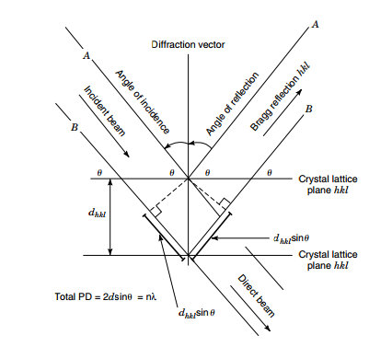

Figure 1. Principles of Bragg’s law

6

A powder diffractometer is manly used for the identification of compounds by their diffraction patterns. It can also be used to determine the particle size of the studied sample. The sample in powder diffraction consists of many small single crystals (1-50 m) with many different orientations. When preparing the sample, the crystals is first (if needed) reduced in size by a pestle. It is then evenly spread on, fore example, a piece of tape. This type of diffractometer gives best results if the sample is very flat. The instruments are designed so that a divergent beam of X-rays impinges on the sample and as a result, a convergent beam of X-ray is diffracted. The beam passes through a slit and then a monochromator which removes unwanted wavelengths. The beam finally reaches the detector and the intensity of the diffracted beam is measured.

The crystallite size can be determined by measuring the full width of the peaks at half height. This can be done both with the help of the computer, or by hand. The broader the diffractions peaks, the smaller the crystallite size is [6].

7

# Method

A picture of the overall experiment is shown in figure 2. In this experiment, six monopockets were connected in series. A monopocket is acting as the positive cell in a NiCd battery and a closer look can be seen in figures 3-5. All the monopockets had a unique set of parameters with the aim of comparing the results registered by a logger. The different parameters for the batteries were time, temperature and electrolyte.

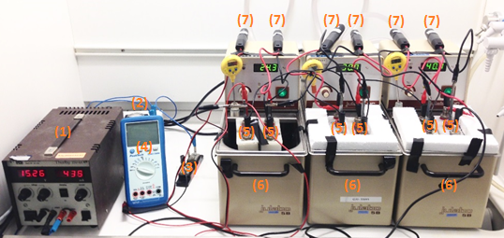

*Figure 2. The experimental setup*

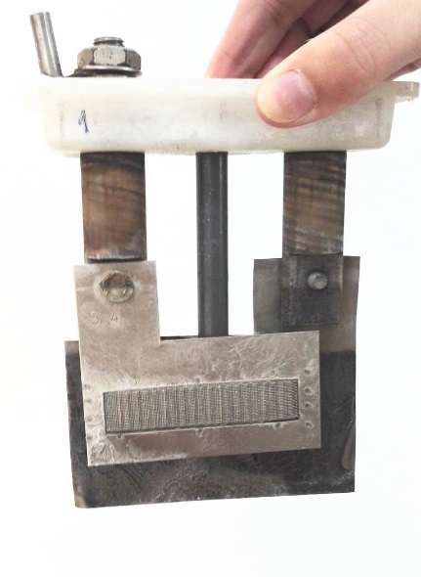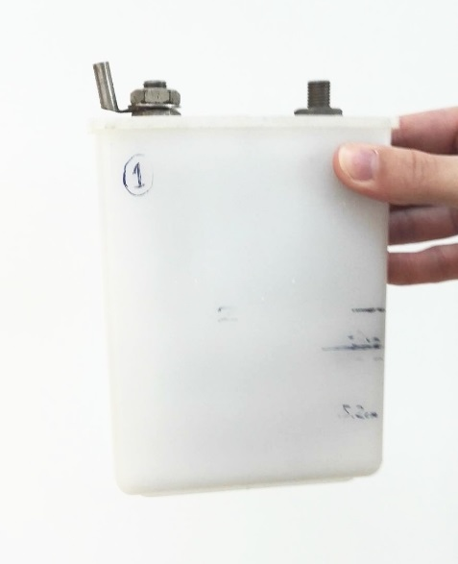

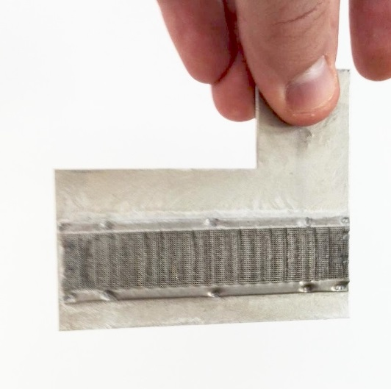

*Figure 3. A monopocket Figure 4. The Ni-sample and the Figure 5. The Ni-sample  
 Ni-reference*

All the batteries were charged and discharge the same way with the deep discharge being the only exception. The experiment was run three times. The first time with no deep discharged at all, while the monopockets of the second run were deeply discharged four hours, and the monopockets in the last run were deeply discharges for 24 hours.

8

The experiment included tests at three different temperatures, 20, 30 and 40. All the temperatures were present in all the three runs. There were three pairs of batteries in each run, and each pair had the same temperature. The different temperatures for the batteries were achieved by placing the monopockets (5) in isolated water baths (6).

Two different electrolytes were used in the experiment. The two batteries that hade the same temperature contained different electrolytes. The two electrolytes were E22 and KOH. The E22 was received by the company SAFT at a correct concentration. The KOH was made in the lab by mixing the right amount of solid KOH in water to get a concentration of 5 M.

To be able to collect the information of the capacity change in batteries, six loggers (7) were first registered in a computer and set to start at a specific time with a registration interval of 30 seconds. The loggers were then placed at each battery, with one cable connecting to the nickel and the other cable connecting to the zinc reference. This resulted in curves in the computer which were to be analyzed.

To achieve the correct amount of current in the experiment, the current was regulated in two different ways. First, the current was roughly set by the source of current (1). It was then [thorough](http://tyda.se/search/thorough?lang%5B0%5D=en&lang%5B1%5D=sv) adjusted by the regulator (2).

A shunt was used to make sure that the current did not exceed the maximum amount current possible for the experiment (3).

A multimeter was connected into the series at start to measure the current accurately. It was then disconnected while the experiment was running because the current was then constant.

The batteries were charged and discharged two times per cycle. At start, the batteries were charged for 14 hours. For the first 4 hours, the current was set at 27 mA. It was then increased to 110 mA for the last 10 hours. After this first charging period, two cables were switched and the batteries were discharging for 6 hours at 110 mA. Now, the deep discharge took place (0h for the first run, 4h for the second run and 24h for the third run). After, the cables were switched back and the batteries were recharged for 9 hours. This time at 110 mA the whole time. Finally, the batteries were discharged for 6 hours at a current of 110 mA. An illustration of the battery charging and discharging cycle can be seen in figure 5 below.

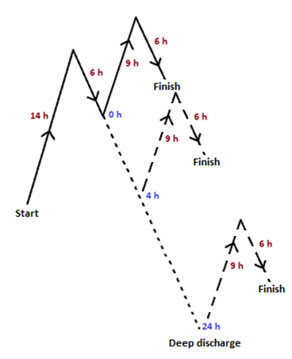

Figure 5. The battery charging and discharging cycle with the different deep discharge times.

9

Results and Discussion  
The results from this project is obtained from the loggers (voltage) and from the XRD analyze (particle size).

*Capacity*

The capacity describes the specific energy of the battery cell and is measured in Ampere hours. To calculate the capacity of a cell, a constant current is lead through the sample during discharge and the time for how long the battery can yield that current is measured. The time (in hours) is then multiplied by the current which will give Ampere hours.

The results from the first cycle, before the deep discharge, are expected to give the same capacity for the same temperature and electrolyte since the samples has been treated the same way. The samples with 0, 4 and 24 h deep discharge all have the same properties during the first discharge with the exception of the electrolyte. Although one can see in figure 6 and 7 that they differed in the experiment which may depend on that the amount of nickel in the monopocket could vary a little, and that the samples were not prepared at the same time which may have had an effect on the preparation.

In the second discharge, after any deep discharge, the capacity is expected to decrease compared to the capacity without discharge due to both the deep discharge but also from the fact that the first cycle is charged with different Ampere and time than the second.

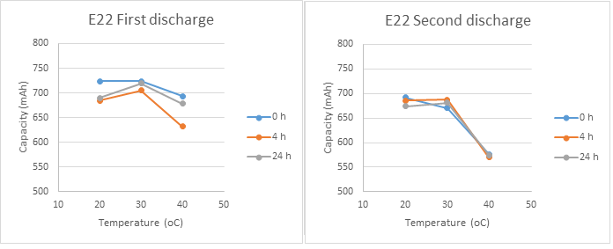

Figure 6. Capacity result for the first and the second cycle with the E22 electrolyte.

10

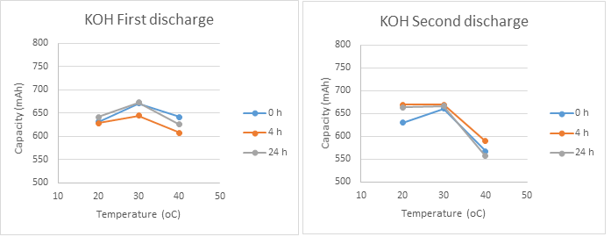

Figure 7. Capacity result for the first and the second cycle with the KOH electrolyte.

A capacity loss will correspond to the reduction of how much current taken up by the NiOH-mass during the charge and will therefore depend on the charging of the battery cell. The reduction of current taken up by the mass would depend on the structure of the mass itself which is expected to change during deep discharge. A higher temperature is also expected to give a lower capacity, this because during the charging cycle of the electrode mass a higher temperature decreases the amount of charges that are able to enter or diffuse into the material and if there is a lower concentration of charges this leads to a reduction of capacity during discharge. The graphs also show an increase of capacity for the samples with 30, and a reason for that could be that with an increase in temperature it’s easier for the charges to diffuse out of the material and give a slight increase of the capacity around 30. But when the temperature increases further, the negative effects during charging out ways the positive capacity effect induced by a higher temperature.

The reason why this is not correct in all cases may depend on the error from the first cycle, since they weren’t the same for the same temperature and electrolyte. There is some difference between the samples or the preparation of the experiment and this error will transfer to the next cycle as well. The fact that the samples in the second charge have been subjected to two charging cycles and one discharge cycle could also contribute to the decrease of capacity even in the sample that haven’t been subjected to a deep discharge, the 0 h sample.

11

## Utilization

Utilization in a battery can be defined as:  
  
where actual achieved capacity is the capacity in mAh from the start of discharge to Vcutoff (1.5 V) and maximum capacity, mAh from the start discharge to 0.7 V. The utilization gives a measurement of how much of the active substance, NiOH that have been utilized. Since the cutoff voltage is 1.5 V the capacity between 1.5 V and 0.7 V where the battery is considered empty gives how much of the charge that the battery have been able to use.

To determine the capacity between Vcutoff and V0.7 the discharge curves where used accordingly to below, figure 8, where a is the time or capacity from start discharge to Vcutoff and b is the time or capacity from start discharge to V0.7. The utilization is then equal to a/b in the figure below.

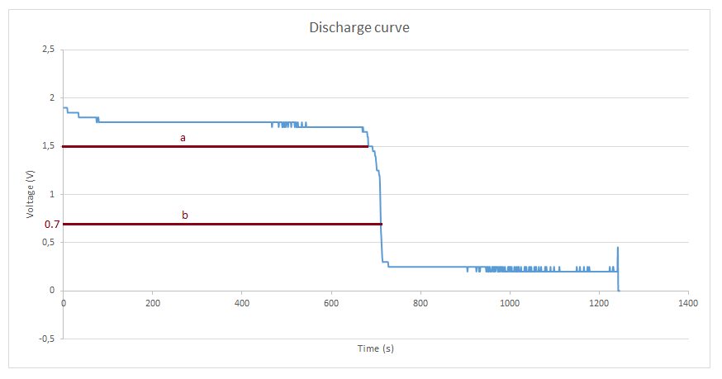

Figure 8. Discharge curve with explaining values for a and b.

Below the graphs for utilization are showed, starting with samples with electrolyte E22, figure 9 show the utilization for the samples. In the leftmost curve, the first discharge all the samples are subjected to the same conditions. This means that in the first discharge curve the samples 0 h, 4 h and 24 h the only difference between them is the temperature, in theory then the 0 h, 4 h and 24 h samples should have the same utilization at the same temperature. The second curve, the rightmost is after the deep discharge of 0 h, 4 h and 24 h.

12

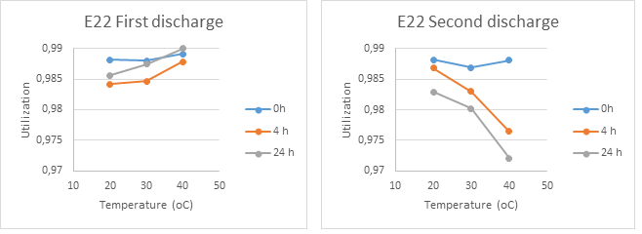

Figure 9. Results of the utilization for the first and the second discharge with the E22 electrolyte.

In figure 10 below, the utilization graphs for the samples with the electrolyte KOH are showed. The same as for the samples above, in the left graph the samples have the same conditions only varying the surrounding temperature. The right curve, the second discharge is after the deep discharge.

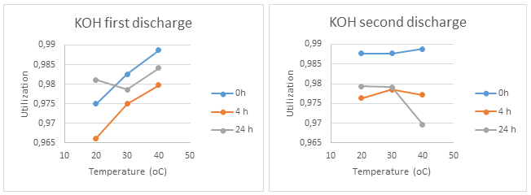

Figure 10. Results of the utilization for the first and the second discharge with the KOH electrolyte.

The degree of utilization is high for all samples, with no value below 96 %. This could be explained by the small difference in time between the cutoff voltage, 1.5 V and the Vempty, 0.7 V. This is explained by the discharge curve in figure 8 above. A high degree of utilization means that a high degree of existing charge in the electrode material is used. During the charging cycle, electrons enter the NiOH-mass of the positive electrode and are during discharge utilized to a degree, simply meaning how much of the charges are available for usage during discharge.

When looking at the first discharge cycle for both E22 and KOH there is a trend of increased degree of utilization with increasing temperature. This could be due to the higher temperature and its effect on the charges in the NiOH-mass. With a higher temperature it’s easier for the “last charges” to contribute to the capacity to Vcutoff. Last charges are the electrons that are the last to leave the electrode and contribute to the effect, and with an increased temperature they can easier leave, or diffuse out of the material of the electrode and therefor increase the degree of utilization.

13

The trend in the second discharge curves, after the samples have been subjected to deep discharge for 0, 4 and 24 h, is different. There seem to be a decrease of utilization with an increasing deep discharge time and with increasing temperature. This trend exist both for E22 and for KOH as electrolyte. However, the blue curve representing 0 hours of deep discharge does not have the same trend meaning that during the deep discharge some transformation of the conductive material within the electrode occurs. This transformation decreases the conductivity of the material and decreases the possibility for electrons to diffuse out of the material and therefor decreases the amount of charges that contribute to the capacity or the time to reach Vcutoff and this decreases the degree of utilization.

## Particle size

The size of the particle is expected to have an effect on the mentioned results. The size is measured after the second cycle. From the XRD-measurements the particle height and width were calculated using Scherrer equation:

Where is the mean crystalline size, K is a shape factor, is the wavelength, β is the broadening at the half maximum and is the Bragg angle. The wanted structure of the particles is a rod like structure where the length in the 001 direction is larger than the 100 direction. The ratio between the directions will give a hint on how the structure looks.

Figure 11 shows a simplified picture, but differs from our samples that is hexagonal.

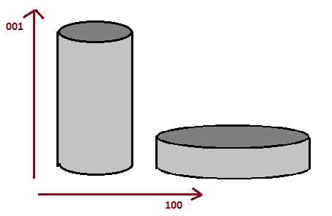

Figure 11. Simplified picture of the difference between the rod like structure and the disc like.

14

Figure 12 and 13 shows the ratio between the particles.

Figure 12. Ratio between the lengths in the 001 and 100 direction with E22 as electrolyte.

Figur 13. Ratio between the lengths in the 001 and 100 direction with KOH as electrolyte.

From these results it is safe to assume that the particles in the mono pockets are more disc like than rod like and that the ratio tend to decrease with increasing temperature. The decreasing ratio means that the shape becomes more flat and is expected to give a lower utilization. The reason for this is when the charge carrying particles, the NiOH mass are present as flat short discs the diffuse range for the charges increases. This could induce a lowering in capacity since the charges simply cannot leave the electrode mass during discharge. The values of particle size ratio also corresponds to the results from the utilization curves after deep discharge, the second discharge curves.

15

# Conclusion

The results from the experiment and the XRD indicates a loss in capacity and efficiency when the samples are subjected to a deep discharge. The particle ratio also decreases with increasing deep discharge time. The decrease in particle ratio corresponds to how the particle is ordered after the deep discharge, the particles takes on a disc-like shape instead of the preferred rod-like shape. The disc-like shape decreases the diffusion possibility for the charges within the electrode during discharge leading to a lower capacity for the samples. The results also indicates that the surrounding temperature affect the capacity and utilization of the samples in such a way that a temperature of 40 have a small negative effect of the capacity during the first charge where all samples have the same conditions. 30 seems to give a slight increase of capacity and this could be due to at that temperature it’s easier for the charges to diffuse out of the electrode and therefor increase the capacity.

There is a clear drop in utilization for the samples in the second discharge curves for both electrolytes, except for the sample that haven’t been subjected to any discharge the 0 h sample. This indicates that a deep discharge affects the utilization of the samples.

Besides the obvious decrease in utilization there is no real indicator if the changes in capacity of the electrode are due to temperature or if the deep discharging affects the nickel hydroxide mass in such a way that it decreases the efficiency of the cell. The truth probably lies in a combination of the two theories; the deep discharge contributes to more disc-like structures that decreases the capacity for the cell but also with an increased temperature the charging will not be as effective contributing to a decreased capacity since the amount of charges in the nickel hydroxide mass decreases compared to lower temperatures.

16

# References

[1] Österberg, Carin. 2013. *Development of a method for addition of lithium hydroxide in the  
 manufacturing process of the positive electrode in nickel-cadmium batteries.* Lic.-avh. Master  
 thesis in engineering, nano science, faculty of engineering, Lund University, division of polymer  
 & materials chemistry.

[2] Recharge aisbl, 2013; Nickel cadmium cell (NiCd); The European Association for Advanced  
 Rechargeable Batteries; [http://www.rechargebatteries.org/knowledge-base/batteries/nickel  
 -cadmium-cell-nicd/](http://www.rechargebatteries.org/knowledge-base/batteries/nickel%20%20%20%20%20-cadmium-cell-nicd/); 2016-05-16

[3] SAFT; 2016; *Our History*; SAFT; <http://www.fastbatteries.com/group/about-saft/our-history>;  
 2016-05-10

[4] Sjövall, Rune; Employee at SAFT AB; Oskarshamn; 2016; Meeting; April 18

[5] Jenkins R, Snyder R. 1996. *Introduction to X-ray powder diffractometry.* Chemical analysis  
 volume 138, John Wiley and Sons, Inc. New York

[6] Tsuji K. 2007. *X-ray technology.* Kirk-Othmer Encyklopedia of Chemical Technology. <http://onlinelibrary.wiley.com/doi/10.1002/0471238961.2418012519160118.a01.pub2/pdf>. 2016-05-16.

17

# Appendix 1

Matlab script

ctheta=6.25*0.14545;

atheta=15.75*0.14545;

btheta=19.6*0.14545;

K=0.9;

lambda=1.54*10^-10;

% Mätta värden, mm

T1=[7 9 7 9 6.5 6.5 6 9 7.5 8.5 8 8 7.5 8.5 7 9 7 7.5 7];

T2=[2.5 4.5 5 4 5 2.5 4.2 5 5 4.5 5 3.5 3.5 5 5 4 4.5 3 4];

T3=[7.5 9 8 9.5 9 6.5 8 9.5 10.5 9 11 8 8.5 9.5 7 9 10 7 7.5];

graff=[0.6 0.5 0.7 0.6 0.8 0.5 0.5 0.4 0.7 0.7 0.5 0.5 0.7 0.7 0.5 0.7 0.5 0.5 0.8];

% Drar bort toppen för grafit

t1=T1-graff;

t2=T2-graff;

t3=T3-graff;

% Första och andra toppen i radianer

t1l=t1.*0.14545.*pi./180;

t2l=t2.*0.14545.*pi./180;

t3l=t3.*0.14545.*pi./180;

% Längd på första och andra topparna (plan)

t1c=abs(K.*lambda./(t1l.*cos(ctheta)));

t2a=abs(K.*lambda./(t2l.*cos(atheta)));

% Tredje toppen omv. propotionell mot kapaciteten

t3b=abs(K.*lambda./(t3l.*cos(btheta)));

% Kvoten mellan första och andra toppen

kvot=t1c./t2a

%Vänder för att passa excell..

t1cc=t1c';

t2aa=t2a';

t3bb=t3b';

kvote=kvot';

18

Appendix 2  
XRD Graphs for the samples.

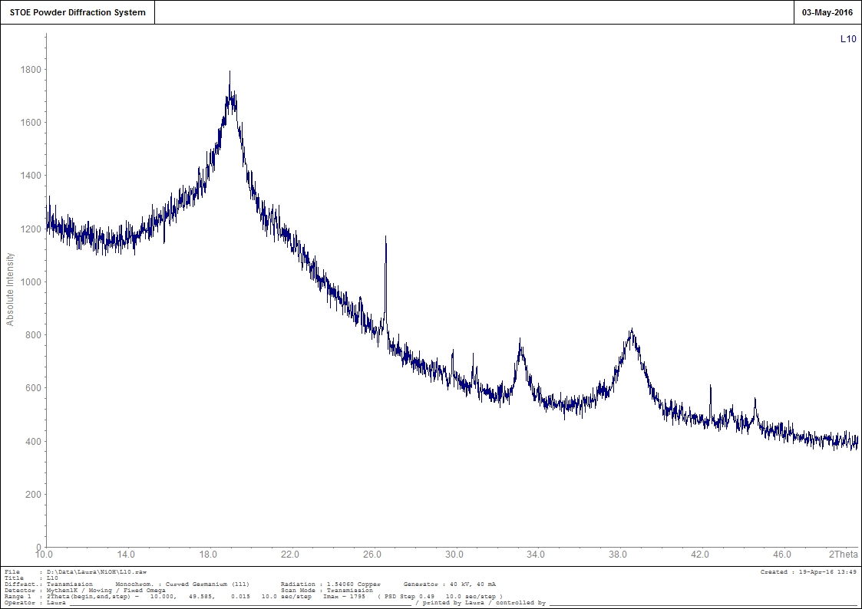

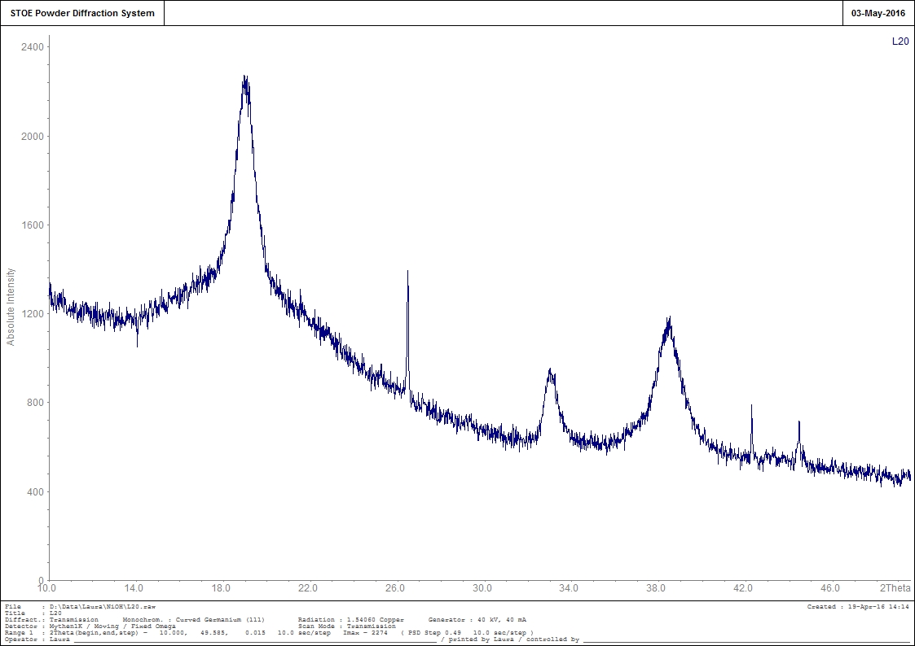

19

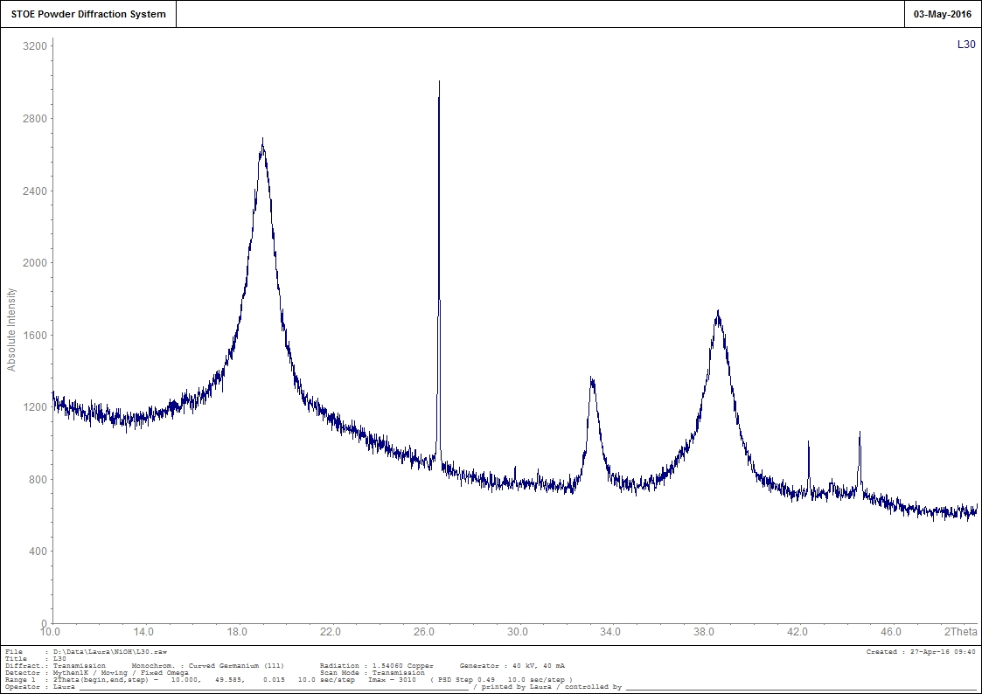

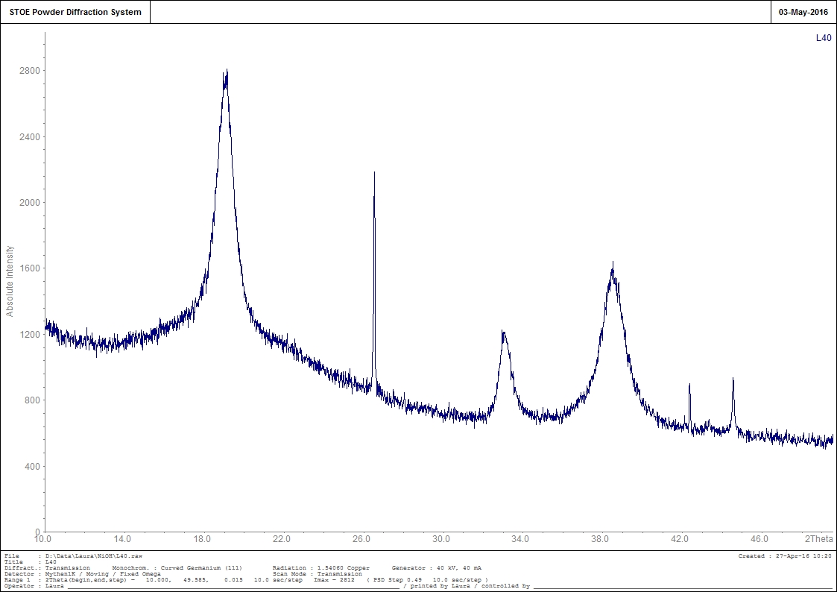

20

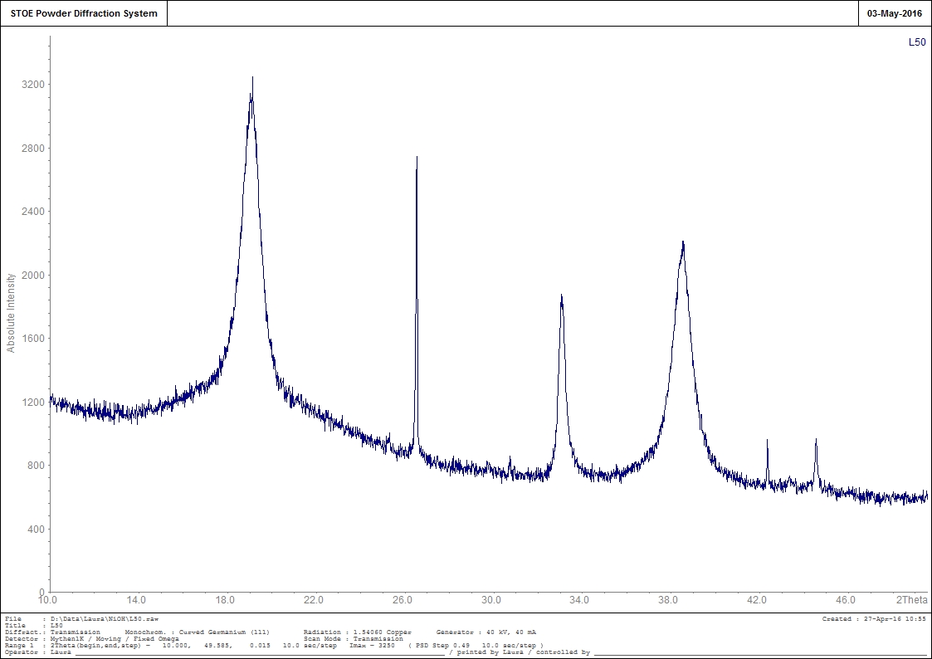

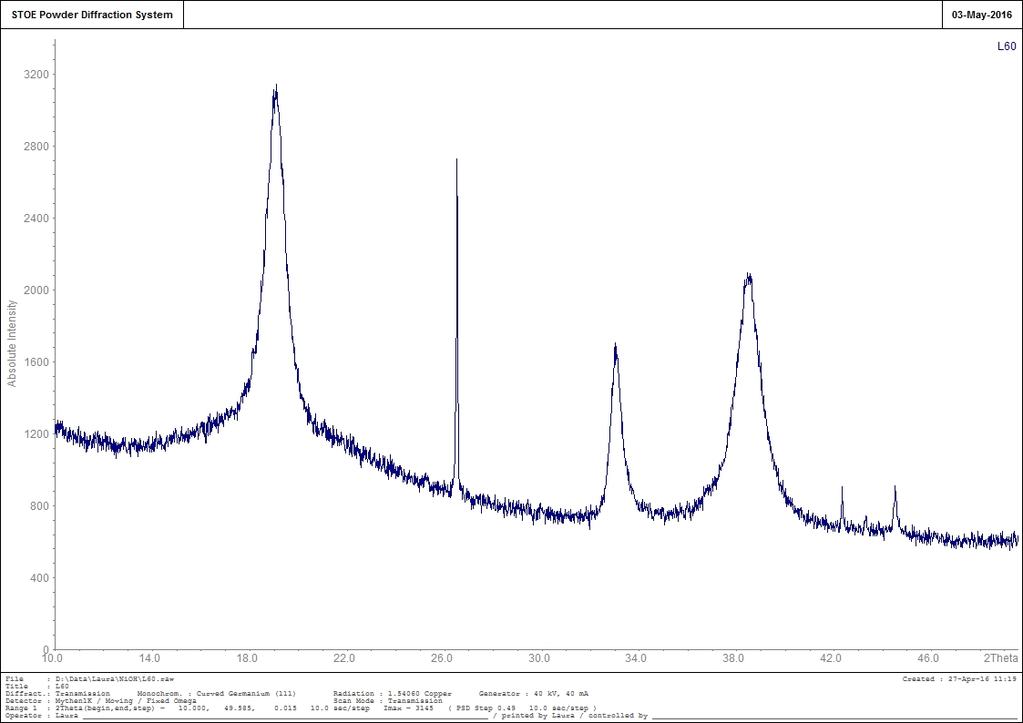

21

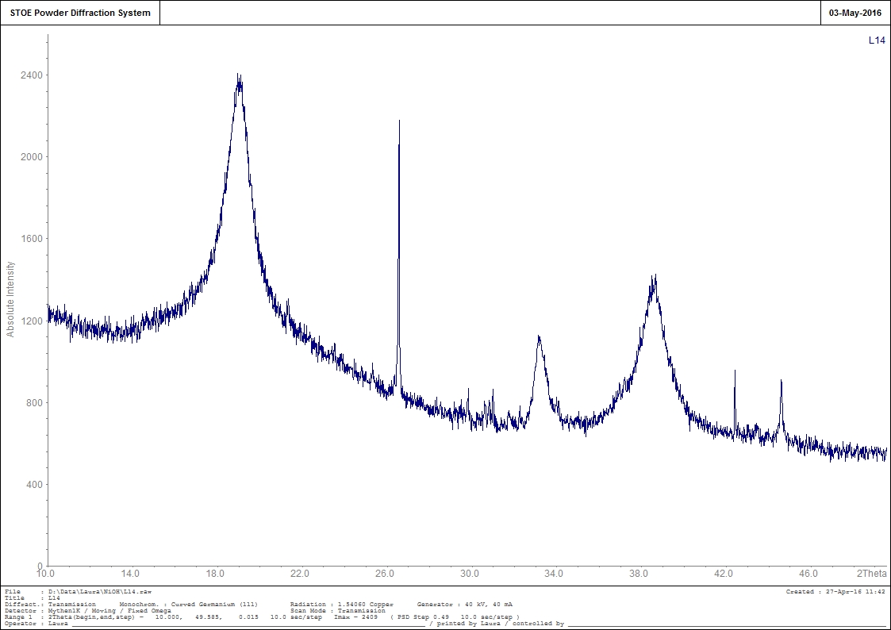

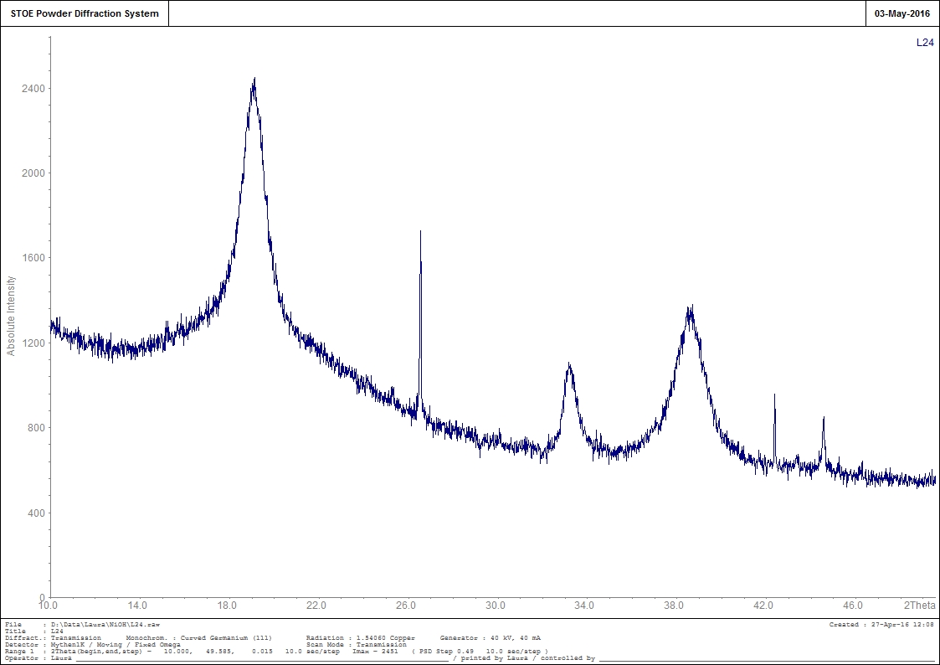

22

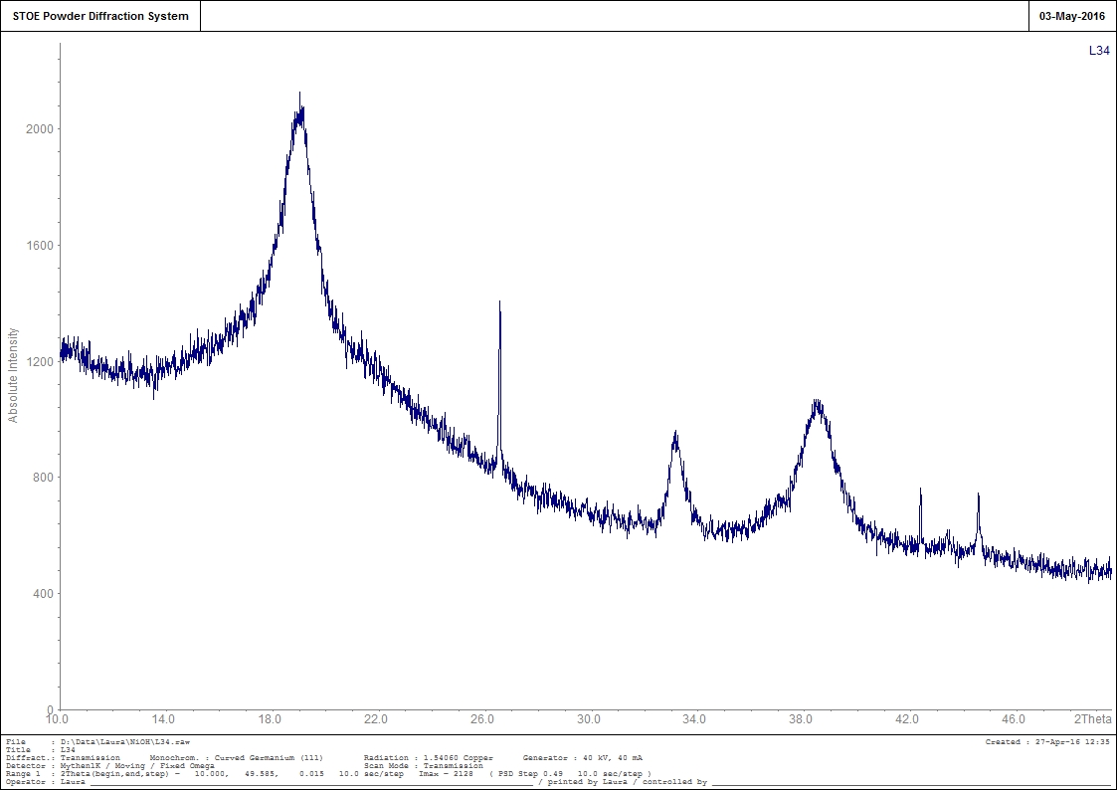

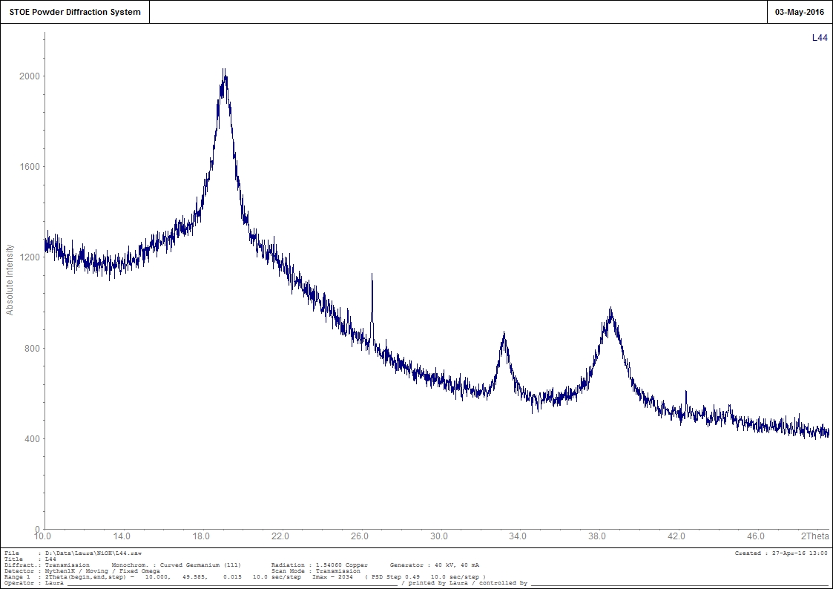

23

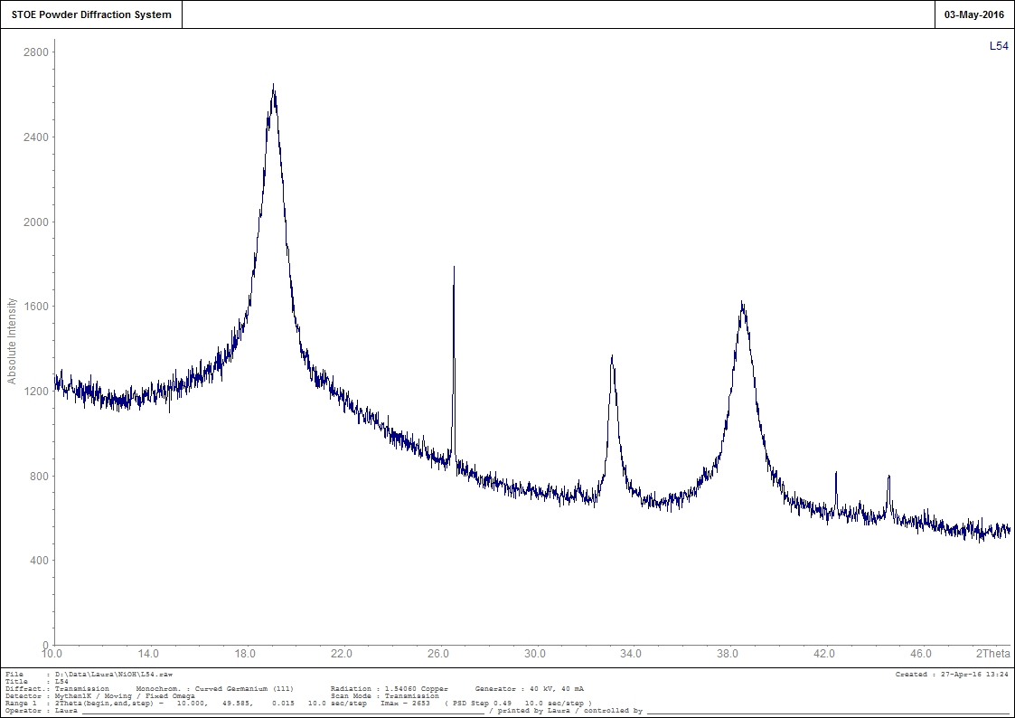

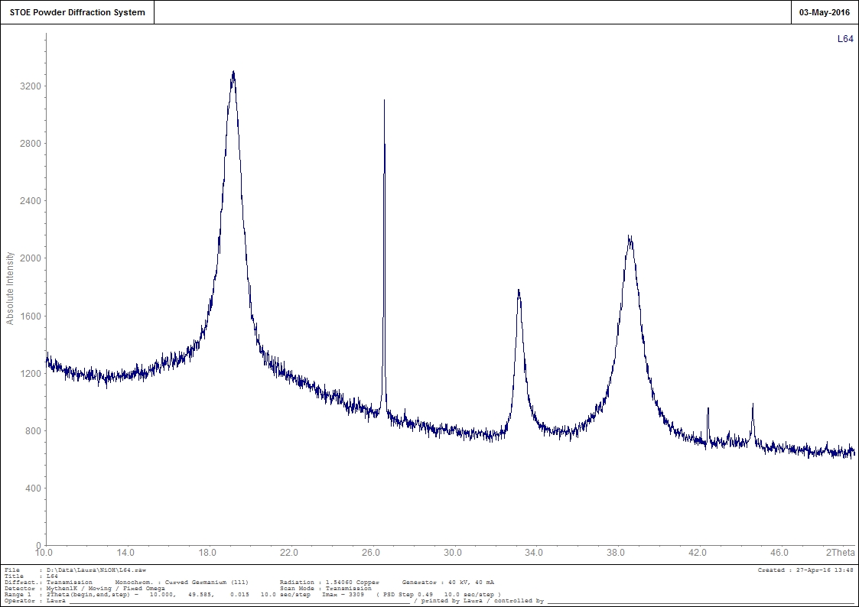

24

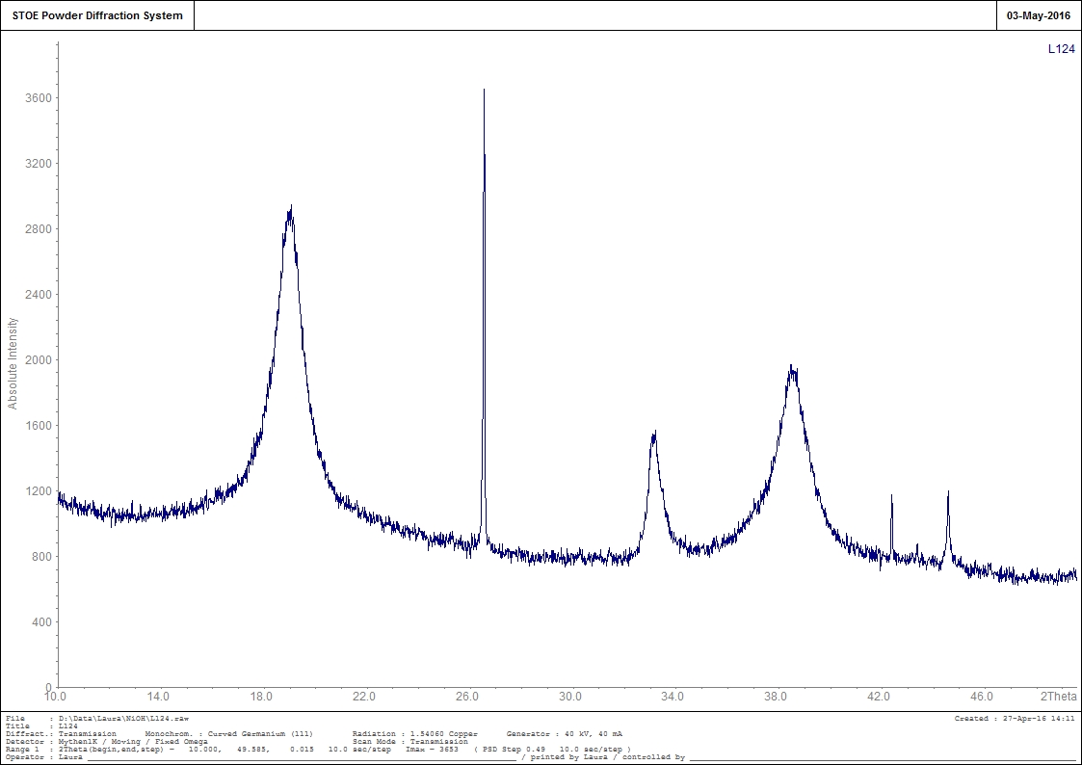

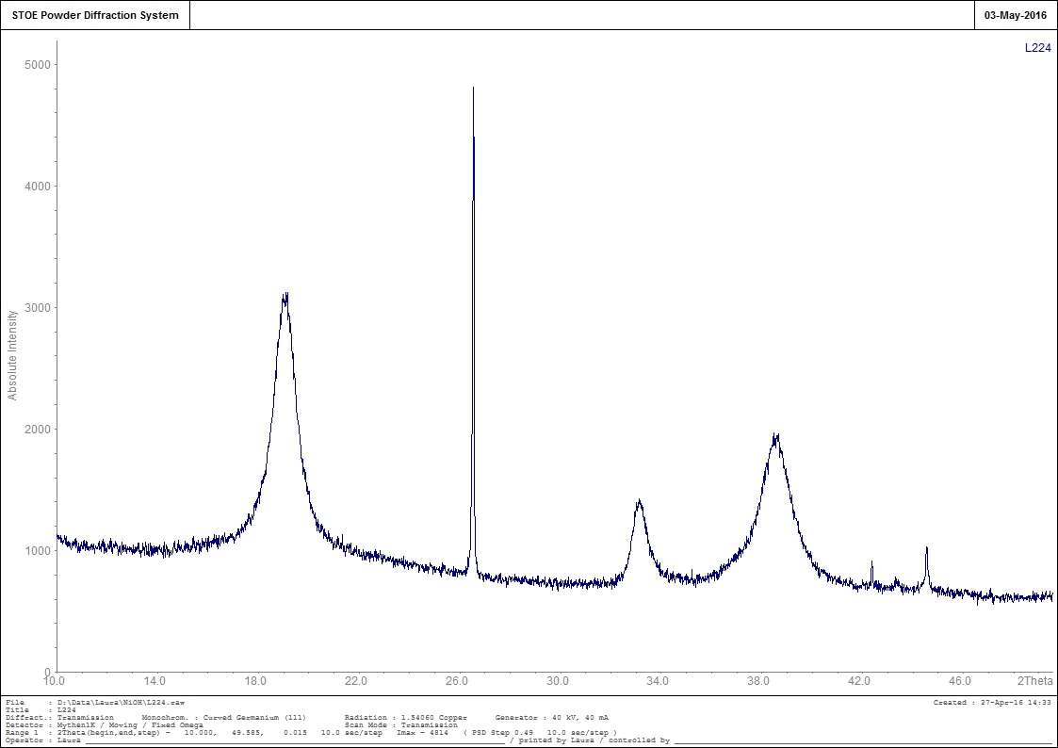

25

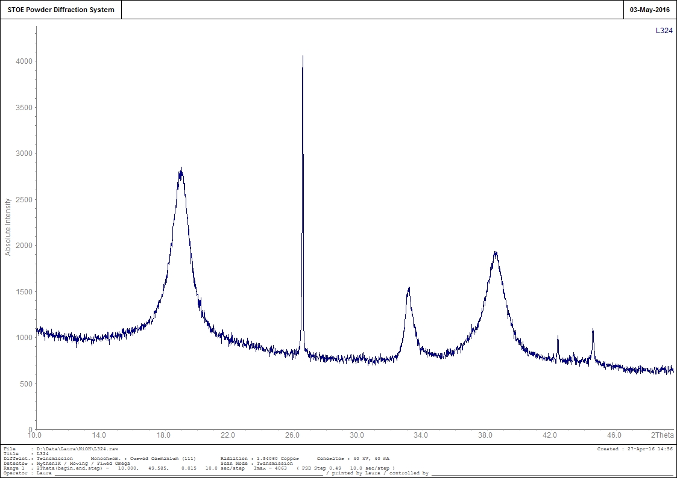

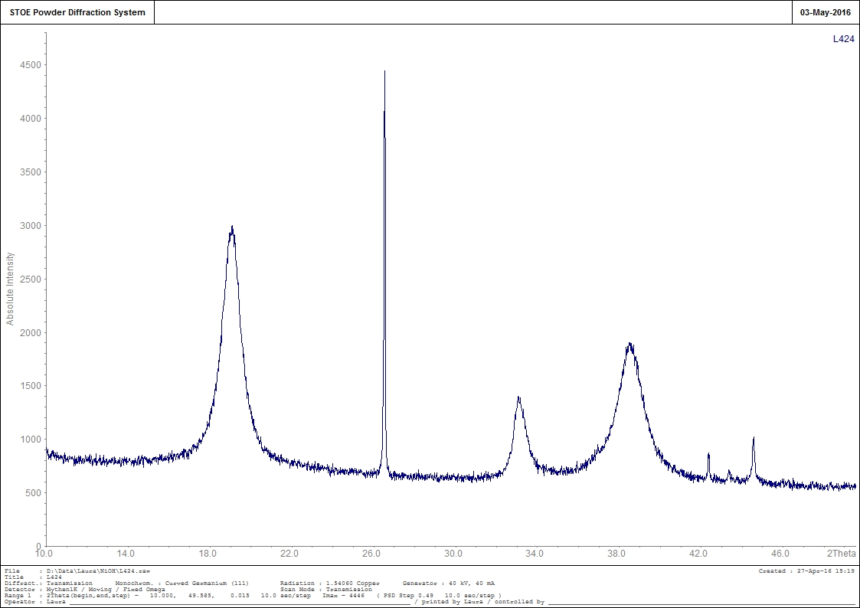

26

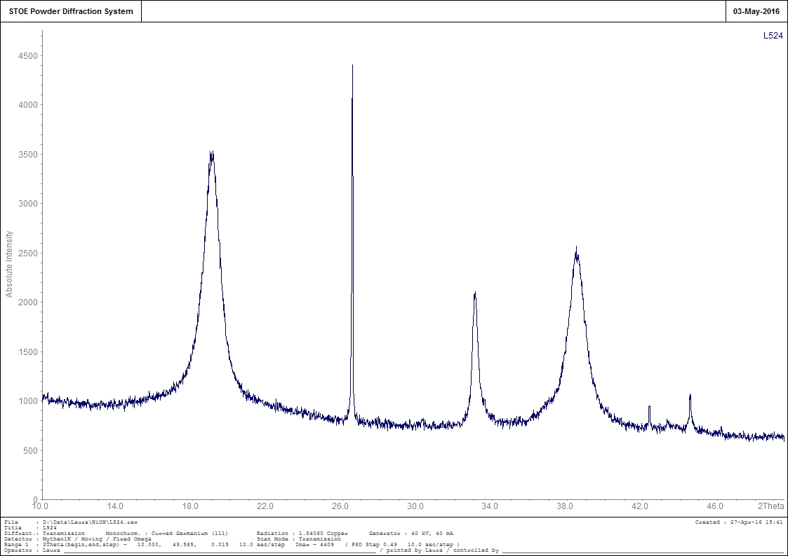

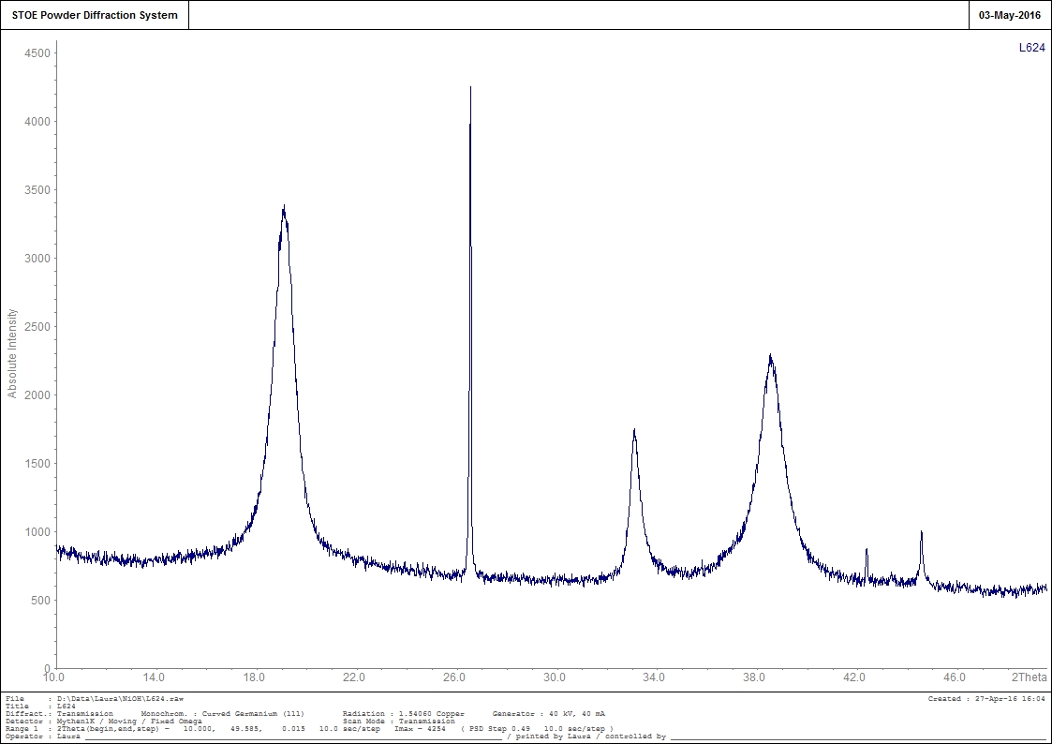

27

Appendix 3   
Summation of results from the loggers.

|  |  |  |  |  |  |  |
| --- | --- | --- | --- | --- | --- | --- |
| Sample | Diff.# start dis. To 1.5V | Diff.# start dis. To 0.7V | Temperatur | Electrolyte | Utilization | Capacity (mAh) |
| L10a | 790 | 799,44 | 20 | E22 | 0,988192 | 724,1666667 |
| L10b | 755 | 764 | 20 | E22 | 0,98822 | 692,0833333 |
| L20a | 689 | 706,68 | 20 | KOH | 0,974982 | 631,5833333 |
| L20b | 687 | 696 | 20 | KOH | 0,987644 | 629,75 |
| L30a | 790 | 799,6 | 30 | E22 | 0,987994 | 724,1666667 |
| L30b | 731 | 740,7 | 30 | E22 | 0,986904 | 670,0833333 |
| L40a | 732 | 745 | 30 | KOH | 0,98255 | 671 |
| L40b | 721 | 730 | 30 | KOH | 0,987671 | 660,9166667 |
| L50a | 756 | 764,3 | 40 | E22 | 0,98914 | 693 |
| L50b | 629 | 636,6 | 40 | E22 | 0,988062 | 576,5833333 |
| L60a | 700 | 708 | 40 | KOH | 0,988701 | 641,6666667 |
| L60b | 619 | 626 | 40 | KOH | 0,988818 | 567,4166667 |
|  |  |  |  |  |  |  |
| L14a | 747 | 759 | 20 | E22 | 0,98419 | 684,75 |
| L14b | 748 | 758 | 20 | E22 | 0,986807 | 685,6666667 |
| L24a | 686 | 710 | 20 | KOH | 0,966197 | 628,8333333 |
| L24b | 730 | 747,7 | 20 | KOH | 0,976327 | 669,1666667 |
| L34a | 769 | 781 | 30 | E22 | 0,984635 | 704,9166667 |
| L34b | 750 | 763 | 30 | E22 | 0,982962 | 687,5 |
| L44a | 703 | 721 | 30 | KOH | 0,975035 | 644,4166667 |
| L44b | 730 | 746 | 30 | KOH | 0,978552 | 669,1666667 |
| L54a | 689 | 697,5 | 40 | E22 | 0,987814 | 631,5833333 |
| L54b | 622 | 637 | 40 | E22 | 0,976452 | 570,1666667 |
| L64a | 663 | 676,7 | 40 | KOH | 0,979755 | 607,75 |
| L64b | 643 | 657,5 | 40 | KOH | 0,977186 | 589,4166667 |
|  |  |  |  |  |  |  |
| L124a | 753 | 764 | 20 | E22 | 0,985602 | 690,25 |
| L124b | 735 | 747,8 | 20 | E22 | 0,982883 | 673,75 |
| L224a | 700 | 713,5 | 20 | KOH | 0,981079 | 641,6666667 |
| L224b | 724 | 739 | 20 | KOH | 0,979296 | 663,6666667 |
| L324a | 785 | 795 | 30 | E22 | 0,987421 | 719,5833333 |
| L324b | 743 | 758 | 30 | E22 | 0,980211 | 681,0833333 |
| L424a | 734 | 750 | 30 | KOH | 0,978667 | 672,8333333 |
| L424b | 727 | 742 | 30 | KOH | 0,979111 | 666,4166667 |
| L524a | 740 | 747 | 40 | E22 | 0,98996 | 678,3333333 |
| L524b | 627 | 645 | 40 | E22 | 0,972093 | 574,75 |
| L624a | 683 | 694 | 40 | KOH | 0,98415 | 626,0833333 |
| L624b | 608 | 627 | 40 | KOH | 0,969697 | 557,3333333 |

28

Appendix 4   
Results obtained from the XRD.

|  |  |  |  |  |
| --- | --- | --- | --- | --- |
|  | 001 (m) | 100 (m) | 101 (m) | Ratio between 001/100 |
| Ref | 1,39E-08 | 4,36E-08 | 8,26E-09 | 0,318581918 |
| L10 | 1,05E-08 | 2,07E-08 | 6,70E-09 | 0,504996725 |
| L20 | 1,41E-08 | 1,93E-08 | 7,81E-09 | 0,732445647 |
| L30 | 1,06E-08 | 2,44E-08 | 6,40E-09 | 0,434357302 |
| L40 | 1,56E-08 | 1,97E-08 | 6,95E-09 | 0,790718557 |
| L50 | 1,48E-08 | 4,14E-08 | 9,50E-09 | 0,357706014 |
| L60 | 1,62E-08 | 2,24E-08 | 7,60E-09 | 0,721915773 |
| L14 | 1,03E-08 | 1,80E-08 | 6,26E-09 | 0,573993371 |
| L24 | 1,31E-08 | 1,93E-08 | 5,82E-09 | 0,67858935 |
| L34 | 1,14E-08 | 2,18E-08 | 6,87E-09 | 0,522801097 |
| L44 | 1,18E-08 | 1,84E-08 | 5,43E-09 | 0,643870825 |
| L54 | 1,18E-08 | 2,76E-08 | 7,60E-09 | 0,429247216 |
| L64 | 1,31E-08 | 2,96E-08 | 7,31E-09 | 0,441872135 |
| L124 | 1,14E-08 | 1,93E-08 | 6,48E-09 | 0,591590715 |
| L224 | 1,37E-08 | 1,84E-08 | 8,77E-09 | 0,742927875 |
| L324 | 1,07E-08 | 2,51E-08 | 6,87E-09 | 0,42666139 |
| L424 | 1,37E-08 | 2,07E-08 | 6,00E-09 | 0,660380333 |
| L524 | 1,27E-08 | 3,31E-08 | 8,77E-09 | 0,383256443 |
| L624 | 1,43E-08 | 2,59E-08 | 8,51E-09 | 0,553867376 |

29